PACKAGES

1.

Matrices.java

package suriya;  
import java.util.Scanner;  
public class matrices {  
 Scanner in = new Scanner(System.*in*);  
 int m, n;  
 int matrix[][] = new int[10][10];  
  
 public void read(int m, int n) {  
 this.m = m;  
 this.n = n;  
 for (int i = 0; i < m; i++) {  
 System.*out*.println("R[" + i + "]");  
 for (int j = 0; j < n; j++) {  
 System.*out*.println("C[" + j + "]");  
 matrix[i][j] = in.nextInt();  
 }  
 }  
 }  
  
 public void print() {  
 System.*out*.println("Matrix:");  
 for (int i = 0; i < m; i++) {  
 for (int j = 0; j < n; j++) {  
 System.*out*.print(matrix[i][j] + " ");  
 }  
 System.*out*.println();  
 }  
 }  
  
 public void addition(int m, int n) {  
 this.m = m;  
 this.n = n;  
 int a[][] = new int[10][10];  
 System.*out*.println("For Matrix1:");  
 for (int i = 0; i < m; i++) {  
 System.*out*.println("R[" + i + "]");  
 for (int j = 0; j < n; j++) {  
 System.*out*.println("C[" + j + "]");  
 a[i][j] = in.nextInt();  
 }  
 }  
 int b[][] = new int[10][10];  
 System.*out*.println("For Matrix2:");  
 for (int i = 0; i < m; i++) {  
 System.*out*.println("R[" + i + "]");  
 for (int j = 0; j < n; j++) {  
 System.*out*.println("C[" + j + "]");  
 b[i][j] = in.nextInt();  
 }  
 }  
 int c[][] = new int[10][10];  
  
 for (int i = 0; i < m; i++) {  
 for (int j = 0; j < n; j++) {  
 c[i][j] = a[i][j] + b[i][j];  
 System.*out*.print(c[i][j] + " ");  
 }  
 System.*out*.println();  
 }  
 }  
 public void subtraction(int m, int n) {  
 this.m = m;  
 this.n = n;  
 int a[][] = new int[10][10];  
 System.*out*.println("For Matrix1:");  
 for (int i = 0; i < m; i++) {  
 System.*out*.println("R[" + i + "]");  
 for (int j = 0; j < n; j++) {  
 System.*out*.println("C[" + j + "]");  
 a[i][j] = in.nextInt();  
 }  
 }  
 int b[][] = new int[10][10];  
 System.*out*.println("For Matrix2:");  
 for (int i = 0; i < m; i++) {  
 System.*out*.println("R[" + i + "]");  
 for (int j = 0; j < n; j++) {  
 System.*out*.println("C[" + j + "]");  
 b[i][j] = in.nextInt();  
 }  
 }  
 int c[][] = new int[10][10];  
  
 for (int i = 0; i < m; i++) {  
 for (int j = 0; j < n; j++) {  
 c[i][j] = a[i][j] - b[i][j];  
 System.*out*.print(c[i][j] + " ");  
 }  
 System.*out*.println();  
 }  
 }  
}

Driver.java

package suriya;  
import java.util.Scanner;  
public class driver {  
 public static void main(String[] args){  
 matrices a= new matrices();  
 Scanner in= new Scanner(System.*in*);  
 System.*out*.println("Enter no. of rows and columns");  
 int m= in.nextInt();  
 int n= in.nextInt();  
 System.*out*.println("Case 1- Read and Print\nCase 2- Add\nCase 3- Sub");  
 int x=in.nextInt();  
  
 switch(x){  
 case 1:  
 a.read(m,n);  
 a.print();  
 break;  
 case 2:  
 a.addition(m,n);  
 break;  
 case 3:  
 a.subtraction(m,n);  
 break;  
 }  
 }  
}

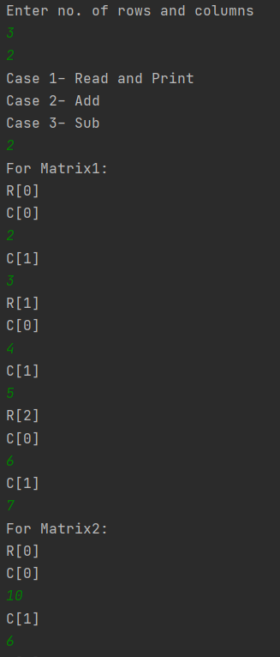

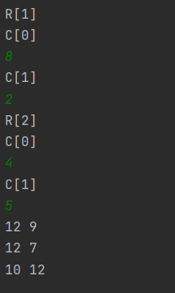

2.

Hospital_database.java

package hospitaldb;  
import Person.*;  
import Doctor.*;  
import Nurse.*;  
import Patient.*;  
import Staff.*;  
import java.util.Scanner;  
  
public class hospital_database {  
 public static void main(String[] args){  
 Scanner in= new Scanner(System.*in*);  
 char d1;  
 person p= new person();  
 staff s= new staff();  
 patient pt= new patient();  
 nurse n= new nurse();  
 doctor d= new doctor();  
  
 p.read();  
 System.*out*.println("Enter 'S' for Staff and 'P' for Patient: ");  
 d1=in.next().charAt(0);  
 if(d1=='S'){  
 s.read();  
 System.*out*.println("Enter 'N' for Nurse and 'D' for Doctor: ");  
 d1=in.next().charAt(0);  
 if(d1=='N'){  
 n.read();  
 System.*out*.println("Nurse Details: ");  
 p.display();  
 s.display();  
 n.display();  
 }  
 else if(d1=='D'){  
 d.read();  
 System.*out*.println("Doctor Details: ");  
 p.display();  
 s.display();  
 d.display();  
 }  
 else {  
 System.*out*.println("Invalid");  
 }  
 }  
 else if(d1=='P'){  
 pt.read();  
 System.*out*.println("Patient Details: ");  
 p.display();  
 pt.display();  
 }  
 else {  
 System.*out*.println("Invalid");  
 }  
  
 }  
}

Person.java

package Person;  
import java.util.Scanner;  
public class person {  
 String name, add;  
 Scanner in= new Scanner(System.*in*);  
 int social_no;  
 public void read(){  
 System.*out*.println("Enter Details\nName: ");  
 name=in.nextLine();  
 System.*out*.println("Address: ");  
 add=in.nextLine();  
 System.*out*.println("Social No: ");  
 social_no=in.nextInt();  
 }  
 public void display(){  
 System.*out*.println("Name: "+name+"\nAddress: "+add+"\nSocial Security No: "+social_no);  
 }  
 }

Patient.java

package Patient;  
  
import java.util.Scanner;  
  
public class patient {  
 Scanner in= new Scanner(System.*in*);  
 int pat_id, age;  
 public void read(){  
 System.*out*.println("Patient Id: ");  
 pat_id=in.nextInt();  
 System.*out*.println("Floor: ");  
 age=in.nextInt();  
 }  
 public void display(){  
 System.*out*.println("Patient Id: "+pat_id+"\nAge: "+age);  
 }  
}

Staff.java

package Staff;  
  
import java.util.Scanner;  
  
public class staff {  
 Scanner in= new Scanner(System.*in*);  
 int staff_id, floor;  
 public void read(){  
 System.*out*.println("Staff Id: ");  
 staff_id=in.nextInt();  
 System.*out*.println("Floor: ");  
 floor=in.nextInt();  
 }  
 public void display(){  
 System.*out*.println("Staff Id: "+staff_id+"\nFloor: "+floor+"\n");  
 }  
}

Doctor.java

package Doctor;  
  
import java.util.Scanner;  
  
public class doctor {  
 Scanner in= new Scanner(System.*in*);  
 String spl;  
 int room;  
 public void read(){  
 System.*out*.println("Specialization: ");  
 spl=in.nextLine();  
 System.*out*.println("Room no: ");  
 room=in.nextInt();  
 }  
 public void display(){  
 System.*out*.println("Specialization: "+spl+"\nRoom no: "+room);  
 }  
}

Nurse.java

package Nurse;  
  
import java.util.Scanner;  
  
public class nurse {  
 Scanner in= new Scanner(System.*in*);  
 String shift;  
 public void read(){  
 System.*out*.println("Shift(Day/Night): ");  
 shift=in.nextLine();  
 }  
 public void display(){  
 System.*out*.println("Shift: "+shift);  
 }  
}

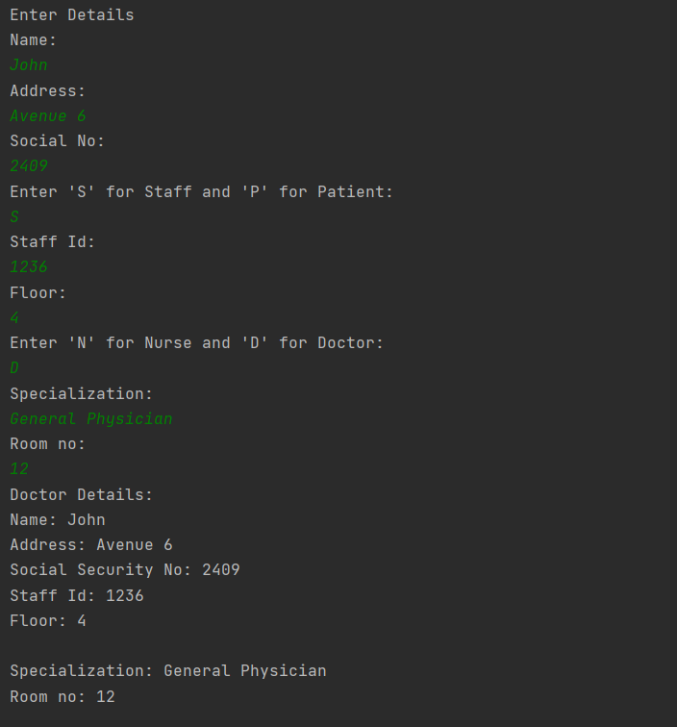

INTERFACES

1.

package suriya;  
  
 interface volume{  
 public void inner_volume();  
 public void outer_volume();  
 }  
 class part implements volume{  
 int s1,s2,s3;  
 part(int a,int b,int c)  
 {  
 s1=a;  
 s2=b;  
 s3=c;  
 }  
 public void inner_volume() {  
 double vol = (3.14*s1*s2*s3)/3;  
 System.*out*.println(vol);  
 }  
 public void outer_volume() {  
 double vol1 = 4*(3.14*s1*s2*s3)/3;  
 System.*out*.println(vol1);  
 }  
 public void show(){  
 System.*out*.println();  
 }  
 }  
 public class Main{  
 public static void main(String[] args){  
 part p = new part(12,13,14);  
 p.inner_volume();  
 p.outer_volume();  
 }  
 }

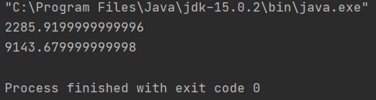

2.

package suriya;  
  
import java.util.Scanner;  
  
abstract class animal{  
 protected int legs;  
 protected animal(int l){  
 legs=l;  
 }  
 abstract void eat();  
 void walk(){  
 System.*out*.println("Walks with"+legs+" legs");  
 }  
}  
class spider extends animal{  
 spider(){  
 super(8);  
 }  
 void eat(){  
 System.*out*.println("Eats insects");  
 }  
}  
interface pet{  
 public String getname();  
 public void setname(String name);  
 public void play();  
}  
class cat extends animal implements pet{  
 cat(String n){  
 super(4);  
 }  
 cat(){  
 this("");  
 }  
 String name;  
 void eat(){  
 System.*out*.println("eats rats");  
 }  
 public String getname(){  
 Scanner S = new Scanner(System.*in*);  
 String s1=S.nextLine();  
 return s1;  
 }  
 public void setname(String n){  
 name=n;  
 }  
 public void play(){  
 System.*out*.println("play");  
 }  
}  
class fish extends animal{  
 fish() {  
 super(0);  
 }  
 void eat(){  
 System.*out*.println("Eats moss");  
 }  
 void walk(){  
 System.*out*.println("Has no legs");  
 }  
  
}  
public class TestAnimals1 {  
 public static void main(String[] args){  
 fish d = new fish();  
 d.eat();  
 d.walk();  
 cat c = new cat("Fluffy");  
 String qwer = c.getname();  
 c.setname(qwer);  
 System.*out*.println(c.name+" "+c.legs);  
 animal a = new fish();  
 animal e = new spider();  
 pet p = new cat();  
 }

